**1.**

WHEN YOU GO TO SERVICES > TIME RANGE (From and To) > Top (2) Categories, Menu gone white so Home Button and Whole Header Section gone white, button is working but the color is change to white disrupting visibility. (THIS ISSUE IS COMING ONLY WHEN I SELECT TIME RANGE).

**2.**

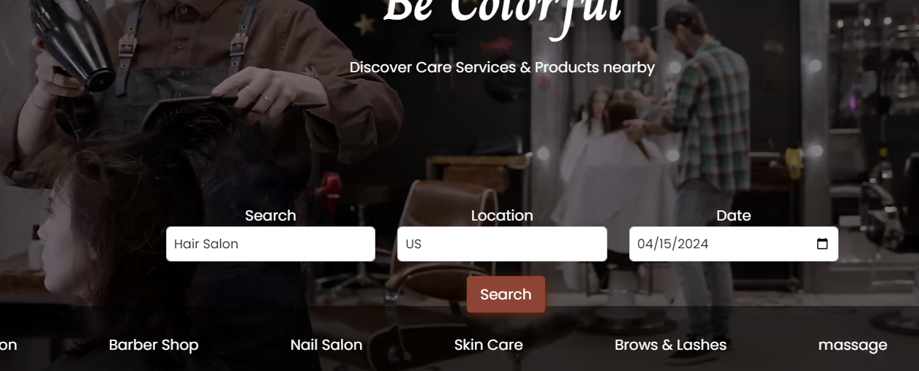

“Search” Button not perfectly aligned looks a bit off. Should be a little above from the shade.

**3.**

“View More” Buttons not redirecting to relevant page, they are still redirecting to the same page.

**4.**

Check if the message is received back at the Panel, plus the “Nessege” should be replaced with “Message”.

**5.**

On Business, “Logging In” Page, the “Forgot Your Password?” Button is not working a/c to what it should be instead it is taking you to the following page:

**6.**

“See Profile” and “Book Now” Buttons are merged together, falling up on each other, plus whole “Services” Page seem to be having width height issue.

**7.**

Check if the “Filter” options are really filtering up the content, because they don’t seem to be filtering up the content.

**8.**

There should be “Quantity” Option or a drop down menu for quantity selection so that users can select the number of total items they would like to buy.

**9.**

After clicking on “Checkout” Button after going in the cart this page appears.

**10.**

Add a “See all Reviews” Button right below the reviews, only top 2 or 3 reviews will be shown rest will need “See all Reviews” button to be clicked first before all reviews are shown.

**11. (TABLET VIEW)**

“Height and Size” of “See Profile” button is misaligned.